3G150B-How to setup 3G Router Mode?
Product line: 3G Question category: Internet settings

Note: 3G150B has three working modes: AP mode, Wireless Router mode, 3G Router mode. The default working mode of 3G150B is AP mode, while you insert a 3G modem to the 3G150B, it will transfer to 3G Router mode automatically. The default LAN IP address of 3G150B is 192.168.2.1. Under the 3G Router Mode, the IP address can be obtained automatically.

The topology should be as below.
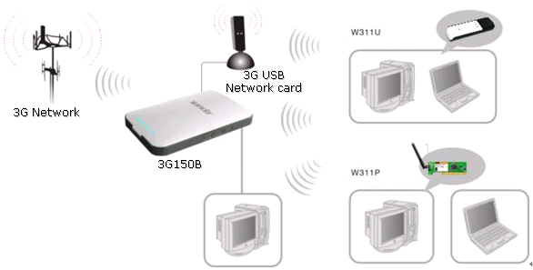
The Steps are as below:
Part 1: Get the parameters of 3G USB modem that you need type in the 3G WAN Setting.
1. Please insert the 3G modem on your computers and install the program for 3G USB Modem
2. Running the program of 3G USB Modem and connect to the Internet.
3. Record the relevant parameters that you need type in the 3G Settings page of 3G150B on the program installed for 3G modem like the picture attached:
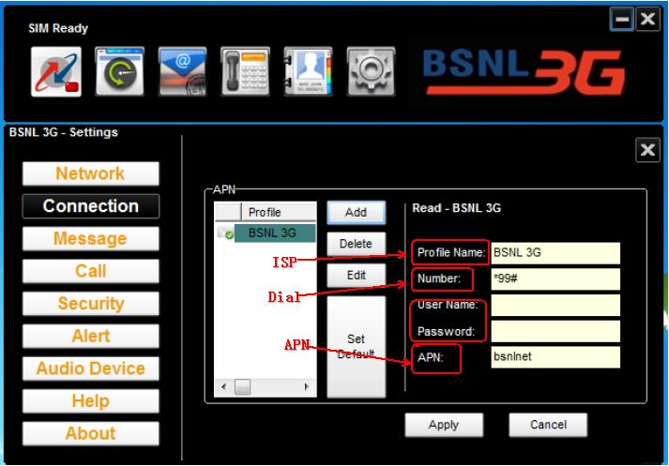
Part 2: Configurations on the 3G150B:
1. Please plug 3G USB modem to the 3G150B, connect your computer to the LAN/WAN port of 3G150B with Ethernet cable. And the computer will obtain IP address from the router automatically.
2. Login to the management page of the 3G150B by inputting http://192.168.2.1 in the address bar of your web browser. The default Password is “admin”.
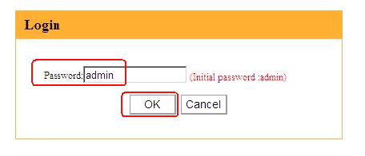
3. In the initial page settings of 3G150B, please click “Advanced Settings”, then you can login to the homepage of the 3G150B.
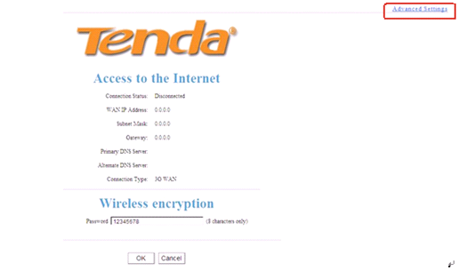
4. Click Advanced Settings→WAN Settings. In the box of the ISP, search your ISP. If you can find yours, just select it. And the relevant parameters will appear automatically. At last click OK to save. As it shown below:
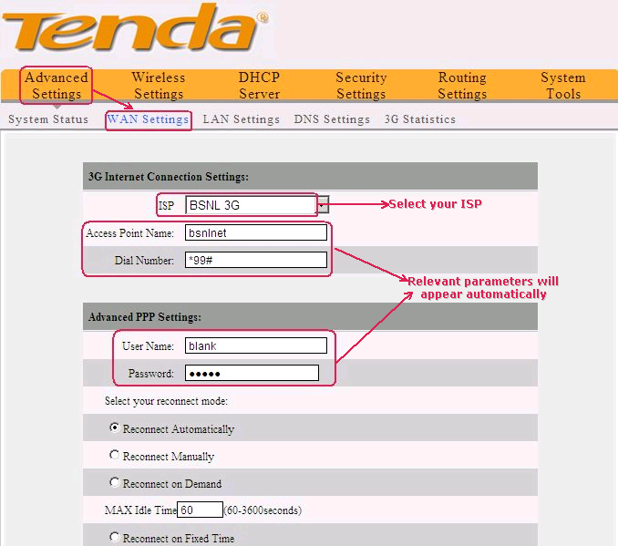 If you can’t find your ISP in the box of the ISP, choose OTHER. And then you should type the relevant parameters which must be match with those of your 3G USB modem. After you finish the type, click OK to save. As it shown below:
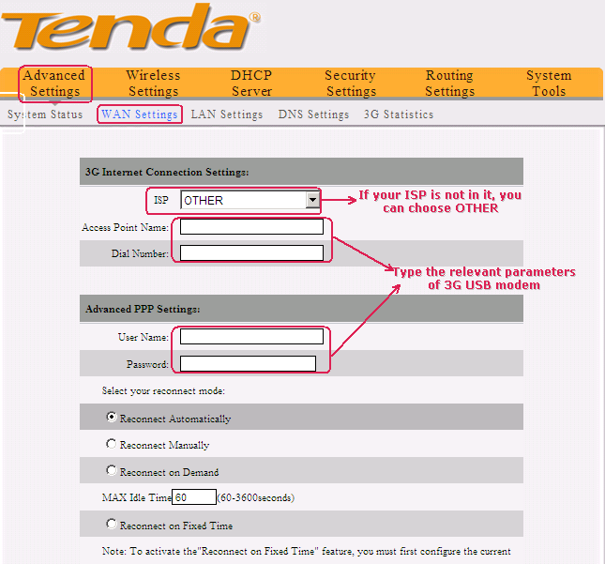
5. Please click Wireless Settings→ Basic Settings, in the new page, please change the SSID (SSID is the name of your wireless network) and select Channel 1 or Channel 6 or Channel 11 as the Channel. Then click OK to save the Settings.

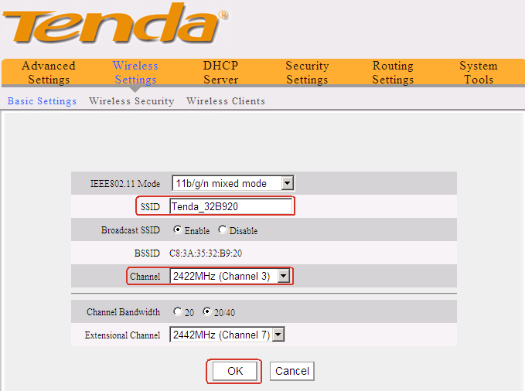
6. Click Wireless Security within Wireless Settings, choose
WPA- PSK as the Security mode, AES as the WPA Algorithms, and in the box of passphrase, please input your password for your wireless network (Password should be at least 8 characters, just letters and numbers). Then click OK to save the Settings.
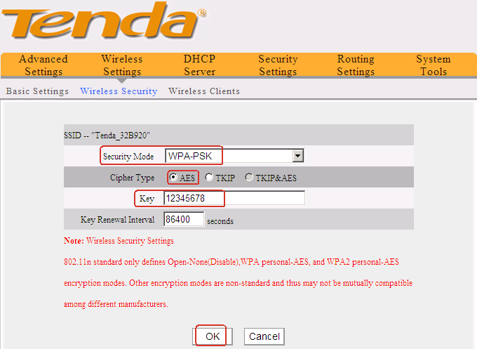
7. The settings for the 3G Router mode of 3G150B are done. You can get online with wire or wirelessly.

